What Will You Do?
Overview: The culture we live in is rapidly and constantly changing. It often seems decisions are made based on our opinions, our feelings, or whatever lines up with the most popular or loudest voice at any given moment.
As followers of Jesus, we ought to be seeking to please the Lord in our thoughts and actions. Choosing to act in ways that are in accordance with God’s truth and for His glory.
Thankfully, our God is like a solid rock that does not move. He calls us to trust in Him and be guided by Him in every situation. He has even promised to equip us with what we need to live for Him, and by His presence and power, give us the ability to courageously obey Him.
This study is about choosing to honour the Lord in our thoughts, words and actions, no matter what the culture around us may or may not be doing.
“Now may the God of peace who brought again from the dead our Lord Jesus, the great shepherd of the sheep, by the blood of the eternal covenant, equip you with everything good that you may do his will, working in us that which is pleasing in his sight, through Jesus Christ, to whom be glory forever and ever. Amen.” (Hebrews 13:20,21)
From these verses notice:
The Nature of God….
What He Has Done/Will Do….
We are equipped with ….
So that we can….

How this Small Group Study is going to work:
- Weekly sermons (see following page) will be introducing a specific topic.
- The topic will be studied in greater detail during the small group meeting that week.

Overview of Sermons/Topics:
(Use this sheet throughout the series to jot down the main points or helpful things you heard during the sermon).
- A Biblical Framework for Examining Motives/Actions in Light of the Gospel
  - Gen. 3 – Questions/Gospel Turn Chart

- The Use of Technology/AI
  - 1 Thess. 5:21 – 22 “Test all things; hold fast what is good. Abstain from every form of evil”

- Life – From Beginning to End; Abortion & MAID
  - Jer. 1:5, “Before I formed you in the womb I knew you…”
  - Psalm 139;13-16 “knit me together in my mother’s womb…”
  - Ex. 20:13 “You shall not murder”

- Growing in Your Family Relationships
  - Col. 3:12 “Put on then, as God’s chosen ones, holy and beloved, compassionate hearts, kindness, humility, meekness, and patience…”

- When relationships Break Down
  - Romans 12:9-21

- Slow Fade: Are the Ways of the World Creeping into Your Life?
  - Eph. 5:8 “For at one time you were darkness, but now you are light in the Lord. Walk as children of light…”

Session 1 – A Biblical Framework for Examining our Motives/Actions
- Read Genesis 3:1-13
- From Sunday’s sermon:
Share a key point or a practical application –

- Using your Bible, the “Gospel Turn” chart, and the description of the six questions included in this lesson, answer the following:
  - Why does God ask Adam and Eve these questions (1-3)?

  - Discuss the responses given by Adam and Eve. How do we respond when confronted by God’s Word?

  - In what ways can we see the gospel in Gen.3?

  - Explain how the gospel of Jesus Christ is a turning point for how we view life (questions 4-6)?

- Read 1 John 2:15-17. How does it help us understand what a Biblical Worldview is?

A Verse to Remember:
And the world is passing away along with its desires, but whoever does the will of God abides forever. (1Jn 2:17)

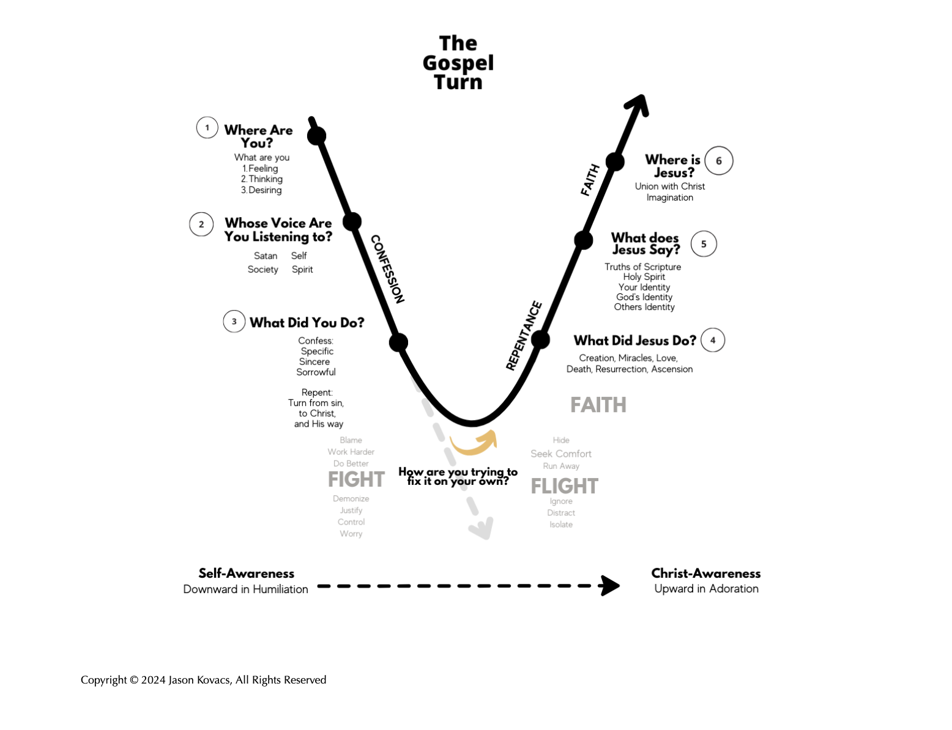

The Gospel Turn
- God’s Three Questions

  - Where are you?
Adam and Eve physically hid from God, so we might think God Tis asking Adam where he’s physically located – and in that regard, it seems like a silly question because of course God knows where they are. However, Adam's response to God’s question focuses on his heart – specifically his emotions: “I was afraid”, his thoughts, “I was naked”, and his desires, “I hid myself.” So perhaps we can understand God’s question more specifically as ‘What are you feeling, thinking, and desiring? In terms of desires, it can be helpful to consider the core desires to be seen, safe, soothed/satisfied, significant, and secure.

  - Whose voice are you listening to?
Adam and Eve have been naked their entire existence and felt no shame about it (Gen 2:25) until this point. So, naturally, God asks “Who told you that you were naked? Have you eaten of the tree of which I commanded you not to eat?” (v 11). Adam responds by shifting the blame to Eve (the woman) and on God (whom you gave), and Eve in turn shifts the blame to the serpent. We see in verse 7 that “their eyes were opened and they knew they were naked”, so what was God’s purpose in asking “who told you”? The blame shifting dialogue is helpful in listing out all the voices in the story – God, Eve, the serpent, and Adam himself. A case could be made for any of the voices except God’s, and that is precisely the point – Adam was listening to anyone except God. In asking “who told you...” God was allowing Adam to recognize which voice(s) he was listening to. Which voices and stories he was giving greatest authority to. We may be listening to Satan, society and social network (the world and others), self, or the Spirit.

  - What did you do? What are you tempted to do?
God turns to Eve and asks the final question, “what is this you have done?” (v 13). We can tie this in with the previous question “did you eat of the tree...?” in that God gives them the opportunity to confess their sin – their distrust of and disobedience to Him. We know confession brings things from the dark to the light and is a critical part of the healing process. (James 5:16). It is important to note that God reserved this question for last. We typically think of this question first because it is easier to identify our behavior or fruit rather than the heart underneath it.

In these 3 questions we get a picture of the God’s heart. He pursues us in our sin and seeks us out with a “spirit of gentleness” (Gal 6:1). He asks us questions that get to the deepest part of our heart’s struggles. He knows the answers to the questions He asks. So why does He ask? He desires 1) relationship and 2) He wants us to name what is in our heart (confession). There is power in naming.

In their responses to God’s questions, we get a glimpse into the hearts of Adam and Eve – full of guilt, shame, and fear, recounting the lies they listened to, confessing their disobedience to the God whom they disobeyed. If we put ourselves in the position of Adam and Eve, it’s a pretty intense, anxiety-inducing scene. Their sin resulted in death’s enslavement of mankind – their shame, guilt, and sorrow are weighing so heavily on them.

The temptation for them and for us is to try to fix things on our own. We fix, we fight, we flee, we fall asleep. What God invites us to is a journey of repentance and faith. But even this is God’s provision.

- The Gospel Turn

God is not done speaking and working His good for Adam and Eve. He turns to Satan in v. 14 and in stark contrast he doesn’t ask a question but makes a statement. In fact, in v 15 He makes a glorious promise -- Jesus – the one who will crush the head of the serpent. Then in v 21 God provides Adam and Eve with skins as garments and clothes them - a picture of us being clothed in Christ’s righteousness. Finally, in v 24 God protects Adam and Eve by sending them out of the garden and ensuring that they cannot access the Tree of Life. The only solution to their sin problem is Jesus.

The next 3 questions are helpful as we meditate on His working, His speaking, and His presence.

- What did Jesus do and what is He doing?
Consider the provision of God for you in Christ. Turn from trusting your work to His work. We are always tempted to do something, but the gospel tells it has been done by Christ. Adam and Eve received the consequences of their sin in vv. 16-19 but it was not to further shame them or have them make penance – he promised to cover their shame. He ultimately bore the penalty and full punishment for our sin. We can rest in His finished work – his perfect life and death for us – and live in light of that.

- What is Jesus saying?
Most of the speaking in Genesis 3 is done by God. He asks Adam and Eve questions and lets them answer but He does most of the speaking. It is shocking given their disobedience how gracious He was. How gentle He was. He cares deeply for them. Adam and Eve listened to God, and we see this in Gen 3:20 where Adam called his wife’s name Eve “because she was the mother of all living.” She had not yet born a child, yet Adam believed God’s word in Gen 3:15!

- Where is Jesus?
Just like Adam and Eve, we all listen to lies, disobey God, and run from Him trying (and failing) to fix the issue ourselves. But the good news is that our story doesn’t have to end in separation from God, slavery to sin, or death. Jesus came and defeated death (Acts 2:24, 2 Tim 1:10), freeing us from slavery (Gal 5:1) and giving us His Spirit to be with us at all times (Matt 28:20, Eph 1:3-14). He absorbed the full weight of all our disobedience, failures, and shame, and has freely given us His righteousness. Through Jesus’ death and resurrection, we can stand before God justified and clean, whole and holy united to Jesus. We may feel far off from God but if we are in Christ He is nearer than we can fathom. He is present. He really is.

Imagination – God is able, for His glory, to do far more with our situation than we may have thought or imagined (Eph.3:20,21)

Copyright © 2024 Jason Kovacs, All Rights Reserved

Session 2: The Use of Technology and AI
There continues to be a lot of discussion around various forms of technology and how they ought to be used. Artificial Intelligence is rapidly changing and affecting everything from a simple google search, to the music we listen to, to researching a topic for a school assignment. How do we know what is true and what is not? Obviously, the culture in which the Bible was written did not have cellphones or computer-generated images, but let’s learn some guiding principles from God’s Word that will help us navigate the quickly changing world of technology.

Definition of technology - the practical application of knowledge especially in a particular area; a manner of accomplishing a task especially using technical processes, methods, or knowledge (Webster’s)

- What is one way that some form of technology has been helpful for you or those around you?

- What is one way that some form of technology has been detrimental to you or those around you?

- We rely on the truth from God’s Word to be our final authority in all matters of life and practice, even in areas that are not explicitly mentioned. Study the following verses from Psalm 119 and note principles that can guide us in using technology:
  - v. 24 –
  - v. 29 –
  - vv. 35-37 –
  - vv. 41,42 –
  - v. 66 –
  - vv. 89-91 –
  - vv. 101-104 –

- Study the following Proverbs and note principles that can guide us in using technology:
  - 7:21-27 –
  - 14:23 –
  - 18:21 –
  - 27:9,10 –

- Do you find yourself too attached to your device? What practical steps have you learned to “unplug”?

Think through the following case study and share your thoughts with the group:
You have been asked to teach a Sunday School lesson on a particular passage from the Bible. You are short on time (the big game is on tonight), and you always have a hard time coming up with a creative way to communicate. How will you prepare? What will your approach and priorities be? Is it okay to use Chat GPT to come up with a lesson plan, complete with illustrations and a dad joke thrown in for good measure? Use Scripture to guide your answer.

Verses to Remember:
But test everything; hold fast what is good. Abstain from every form of evil. (1Th 5:21-22)

Session 3: Life – From Beginning to End; Abortion & MAID

Do some research and summarize current Canadian laws regarding:
Abortion –

MAID –

Was it hard to find? Easy to interpret?

Read Psalm 139. Describe what it is to be “fearfully and wonderfully made”. What other words or phrases help us to understand our life, value and purpose? Who is the owner of us? What implications does this ownership have on us?

Read Ecclesiastes 12. What is the normal pattern of life on this earth? Is happiness a life-long guarantee? Where should our focus be? Use other scripture to support.

Choose EITHER the topic of Abortion OR MAID and develop a biblically based response to someone who is advocating for them. Give attention not only to WHAT is communicated, but HOW it is communicated.

A Verse to Remember:
I praise you, for I am fearfully and wonderfully made. Wonderful are your works; my soul knows it very well. (Ps 139:14)

Session 4: Growing in Your Family Relationships
- From Sunday’s sermon:
Share a key point or a practical application –

- Read Colossians 3. Make a list of God’s instructions to guide:
  - Your personal relationship with God

  - Marriage relationships

  - Parent/child relationships

  - By application, employer/employee relationships

- What are some of the challenges that families have in living out these truths in today’s culture?

- Find an example in the Bible, where God uses one family member to strengthen another one. What did you notice?

- As a community of Believers, we seek to be an encouragement to each other. Take some time together as a smaller group to pray that God would strengthen our families.

A Verse to Remember:
And let the peace of Christ rule in your hearts, to which indeed you were called in one body. And be thankful. (Col 3:15)
Session 5: When Relationships Break Down
We do not always handle conflict well. Our culture seems to live by the rule that if a relationship does not give us what we want, we simply move on to one that will. The end result is often a trail of broken relationships and feelings of emptiness and loneliness. When relational difficulties occur, there are many biblical principles that will help guide us toward reconciliation, healing and forgiveness to the glory of God.
- Read the following passages and mention some of the reasons for, and ways we are instructed to work through relational challenges:
  - James 4:1-12

  - Matthew 7:3-5

  - Romans 12:9-21

- Read over the “Peacemaking Principles” pamphlet provided with this material and think through:
  - What is conflict really about? How much time do you give to trying to “fix the other person” as opposed to “fixing you”?

  - Something that you might not have thought about before

  - What seems to be the hardest part of working through conflict?

  - What if the conflict cannot be resolved to everyone’s satisfaction?

  - Why should reconciliation with others be important to us as Christians?

- Work through the following case study using Scripture and the “Peacemaking Principles” pamphlet to guide your response.

Case #1 Missions Meltdown
Imagine that you receive the following email (or letter or phone message) from a Christian friend.

I wish I had never agreed to serve on our church missions committee! Pat, another committee member, is so irritating! He delights in using cutting humor and seems to look for ways to ridicule others’ ideas and suggestions, especially mine.

When he disagreed with me on a financial issue during last night’s meeting, I finally lost my patience. Knowing that he is self-conscious about not going to college, I said something like, “I can see why these figures are hard for you to understand, Pat, but if you had just a little more education, it would all add up.” He just sat there stunned, and the whole group awkwardly moved on with the discussion. I felt sort of sorry about saying what I did, but I also think he had it coming.

This morning, I found a letter from Pat under my door, which he must have delivered late last night. The letter harshly accusing me of all sorts of wrongs. I can see why he is angry with me belittling him in front of others, but he has made up all sorts of other accusations that are exaggerated or completely untrue. He concludes by saying I am unfit to serve on the missions committee. And he had the gall to copy the committee chairman!

I’m torn between writing him a letter pointing out how he brought this on himself or discussing it on the phone. What do you think I should do?

A Verse to Remember:
Be kind to one another, tenderhearted, forgiving one another, as God in Christ forgave you. (Ep 4:32)

Session 6: Slow Fade – Are the ways of the world creeping into your life?
- From Sunday’s sermon:
Share a key point or a practical application –

- Read the following passages, noting truths that guide us in sorting out behaviour that is honouring to the Lord from that which is not:
  - Romans 15:1-7
  - 1 Corinthians 6:12-20
  - 1 Corinthians 10:23-11:1
  - Revelation 3
- Interact with the following definition:
Sanctification – a progressive work of God and man that makes us more and more free from sin and like Christ in our actual lives.
Do you find that the ideas of the world affect what you do and how you think? Think through topics such as modesty, use of alcohol, swearing.

- Read 1 Thess.4:1-12. How do these verses help us in our understanding of growth in Christ? What has God called us to? What is meant by “more and more” in verse 1?

Verses to Remember:
Blessed is the man who walks not in the counsel of the wicked, nor stands in the way of sinners,
nor sits in the seat of scoffers; but his delight is in the law of the LORD, and on his law he meditates day and night. (Ps 1:1-2)

Peacemaker Training, https://rw360.org/wp-content/uploads/2023/06/Relational-Peacemaking-Case-Studies.doc.
Grudem, Wayne. Systematic Theology: An Introduction to Biblical Doctrine (p. 326).

